Entity Framework

What is Entity Framework?

Entity framework is an ORM framework. ORM stands for Object Relational Mapping.

What is Object Relational Mapping Framework?

Object Relational Mapping Framework automatically creates classes based on database tables, and the vice versa is also true, that is, it can also be automatically generate necessary SQL to create database tables based on classes.

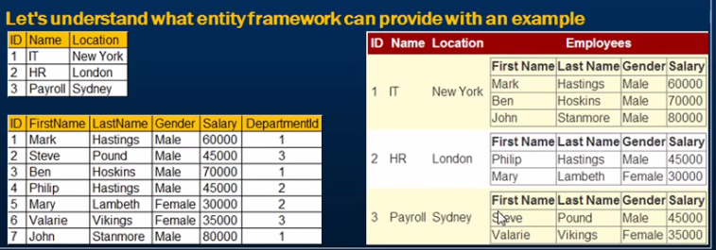

To achieve this

1. We need to create Department and Employee Classes

2. Write ADO.NET code to retrieve data from the database

3. Once the data is retrieved we need to create Department and Employee objects and populate them with data.

Entity framework can do all of the above automatically, if we provide it with the database schema.

Installing NUGET Package Manager

1 .From visual studio tools menu, select Extension Manager

2. Click on Online Gallery in the Extension Manager window

3. Search for NUGET package manager and install.